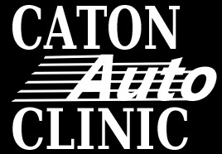

**Inclement Weather Policy- Office Staff**

1. If you decide to come in- you will be paid for your hours here
2. If we run out of productive things for you to help with then you may be sent home.
3. If you are sent home you will be paid for the hours here
4. If you miss any time it will be your choice to use your sick/vacation hours to make up for the time missed.
5. We will not test drive vehicles in inclement weather as it is a safety hazard for our technicians and our customers’ vehicles.
6. We will not have support staff to pick up and deliver vehicles on inclement weather days. Therefore, we will not pick up and deliver vehicles on inclement weather days.
7. In addition to #6, should any fleet representative feel a vehicle or the conditions for driving their fleet vehicle are too dangerous we are to either get the vehicle towed if it is good weather or, wait until weather improves.