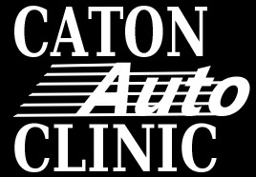

**Caton Auto Clinic- Internet Use Reminder**

Since providing computers and internet access to you we have had a policy on internet usage. The computers, laptops, tablets, and other internet ready devices that we provide are to be used for business principals only. Examples of acceptable use are:

* Business Email
* Business related social media
* Identifix
* Alldata
* IATN
* Google Searches for vehicle repair
* Youtube- only in order to reset maintenance lights or other procedural issues
* Looking for a part online
* Looking for a shop tool online
* Directions
* ACDelco Training Courses

Any unauthorized sites/searches must be done on your own device. Don’t worry there are apps for all your needs including Facebook, Twitter, Google Plus, Amazon, Ebay, ESPN, and Itunes. These searches should be done at non-work times (lunch, smoke break).

Because this is not being followed there are new consequences for failure to comply:

* **First Offence-** Written Warning
* **Second Offense-** You will be sent home for the day with no pay
* **Third Offense-** You will be suspended for a week with no pay
* **Fourth Offense-** Termination